Why Natural Disasters Occur: Exploring Plate Tectonics
by Stephen Sviatko
Topic: Plate Tectonics
Grade Level: 9th
SOLs:
ES.8 The student will investigate and understand geologic processes including plate tectonics.
Key concepts include
- how geologic processes are evidenced in the physiographic provinces of Virginia including the Coastal Plain, Piedmont, Blue Ridge, Valley and Ridge, and Appalachian Plateau;
- processes (faulting, folding, volcanism, metamorphism, weathering, erosion, deposition, and sedimentation) and their resulting features; and
- tectonic processes (subduction, rifting and sea floor spreading, and continental collision).

Time Frame: 2 days or 3 hours
Primary Objective:
Students will
- define and describe plate tectonic activities including earthquakes and volcanoes;
- explore different plate tectonic settings
Opening Set:
The students will find and list natural disasters that have occurred over the past years using different sources such as the internet, magazines, and newspapers. Have them list features that the disasters caused. Once they have found these disasters, they need to group them as geological (earthquakes, volcanoes, tsunamis, etc.) or meteorological (hurricanes, tornadoes, typhoons, etc.). Have the students focus on the geological disasters.
After they have listed the disasters, have them compare and contrast geological and meteorological disasters such as earthquakes and hurricanes or tornadoes and volcanoes, etc.
Activity:
After dividing the class into groups. The teacher will define what plate tectonics is. Plate tectonics are the movement of Earth's plates that can cause geological disasters. The plates rub together under the Earth's crust to cause plate tectonics. Each group will write in their own words what plate tectonics is. After coming up with the definition, they will come up with a diagram of plate tectonics and how it works. As a class we will review what each group thinks plate tectonics is and they will explain their diagrams.
Discussion:
Plate tectonics work as a result of hot mantle asthenosphere ascending beneath mid-ocean ridges to form the plates. These plates then subside into the mantle again at subduction zones, pulled by the excess density of the mafic ocean crust, which transform to eclogite. The teacher will explain the main components of plate tectonics. This will give the students the understanding of why natural disasters occur. Also will define any terms from the definition that the students have trouble with. The components are described below.
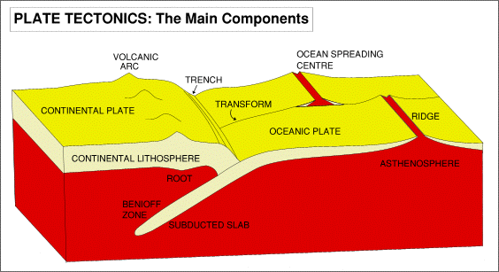
Plate tectonics are the cause of major geological disasters that occur across the world. The plates are located all across the world. The map is located below.
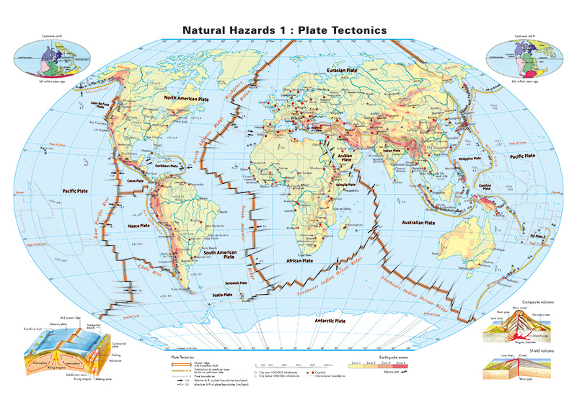
Student Assessment:
To gain an understanding of the student's knowledge, each student will write a summary of plate tectonics and how they create the natural disasters across the world.

